**DAILY ONLINE ACTIVITIES SUMMARY**

|  |  |  |  |  |  |  |  |
| --- | --- | --- | --- | --- | --- | --- | --- |
| **Date:** | **19/06/2020** | | | | **Name:** | **Anusha. K** | |
| **Sem & Sec** | **4th SEM 'A' Section** | | | | **USN:** | **4AL18CS009** | |
| **Online Test Summary** | | | | | | | |
| **Subject** | | **Microcontroller and embedded systems** | | | | | |
| **Max. Marks** | | **20** | | **Score** | | **19** | |
| **Certification Course Summary** | | | | | | | |
| **Course** | **Introduction to neural networks and deep learning** | | | | | | |
| **Certificate Provider** | | | **greatlearning academy** | **Duration** | | | **9.5 hours** |
| **Coding Challenges** | | | | | | | |
| **Problem statement 1:Write a C Program to Count total set bits in all numbers from 1 to n.** | | | | | | | |
| **Status: completed** | | | | | | | |
| **Uploaded the report in Github** | | | | **yes** | | | |
| **If yes Repository name** | | | | [**https://github.com/anusha20219/Lockdown-coding**](https://github.com/anusha20219/Lockdown-coding) | | | |
| **Uploaded the report in slack** | | | | **yes** | | | |

ONLINE TEST DETAILS: Microcontroller and embedded systems test was conducted from 3 pm to 3:30pm. There were 20 questions and time allotted was 30 mins. The questions were mcq type.

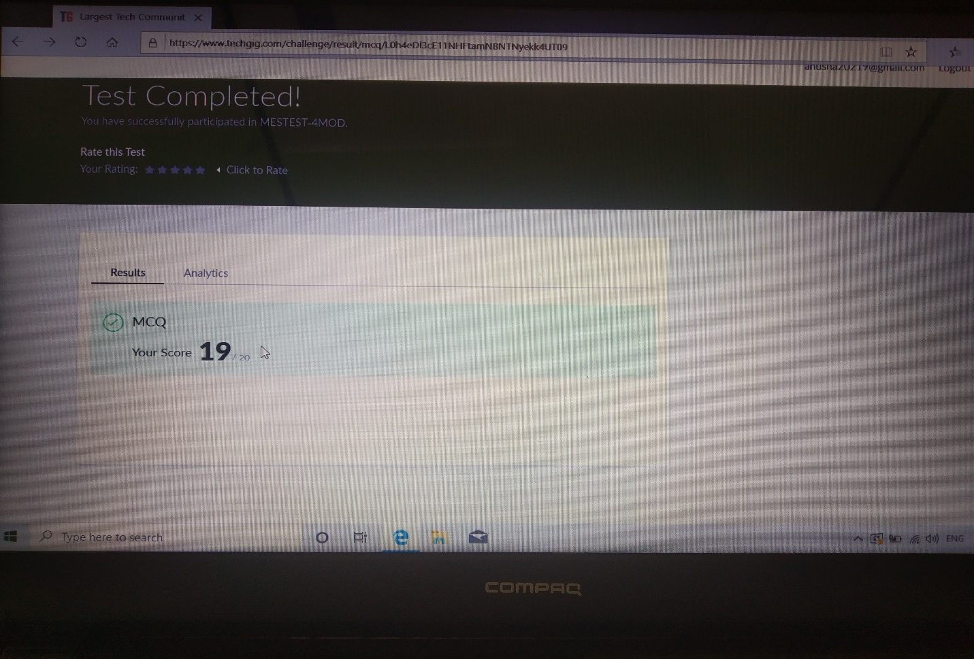

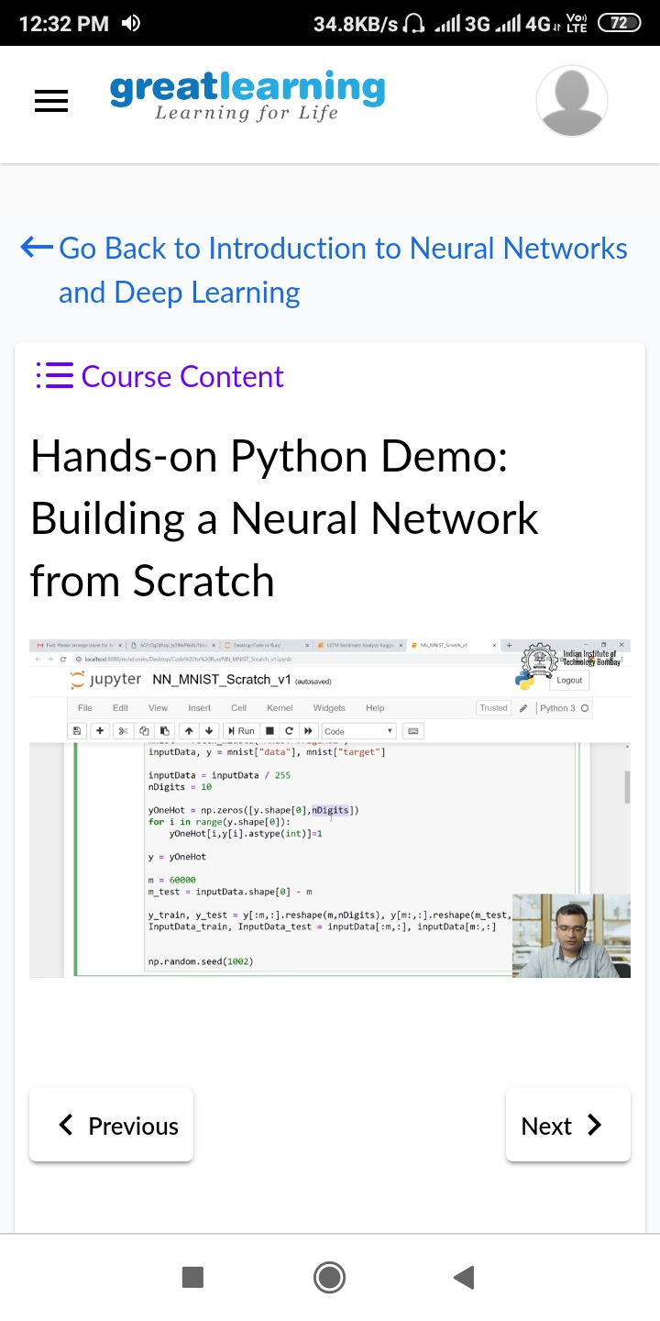Certification course details: Today I started with introduction to neural networks and deep learning certification course in which I studied the topics Python, Linear regression, Logistic regression, Basic Algebra.

Coding challenge details:

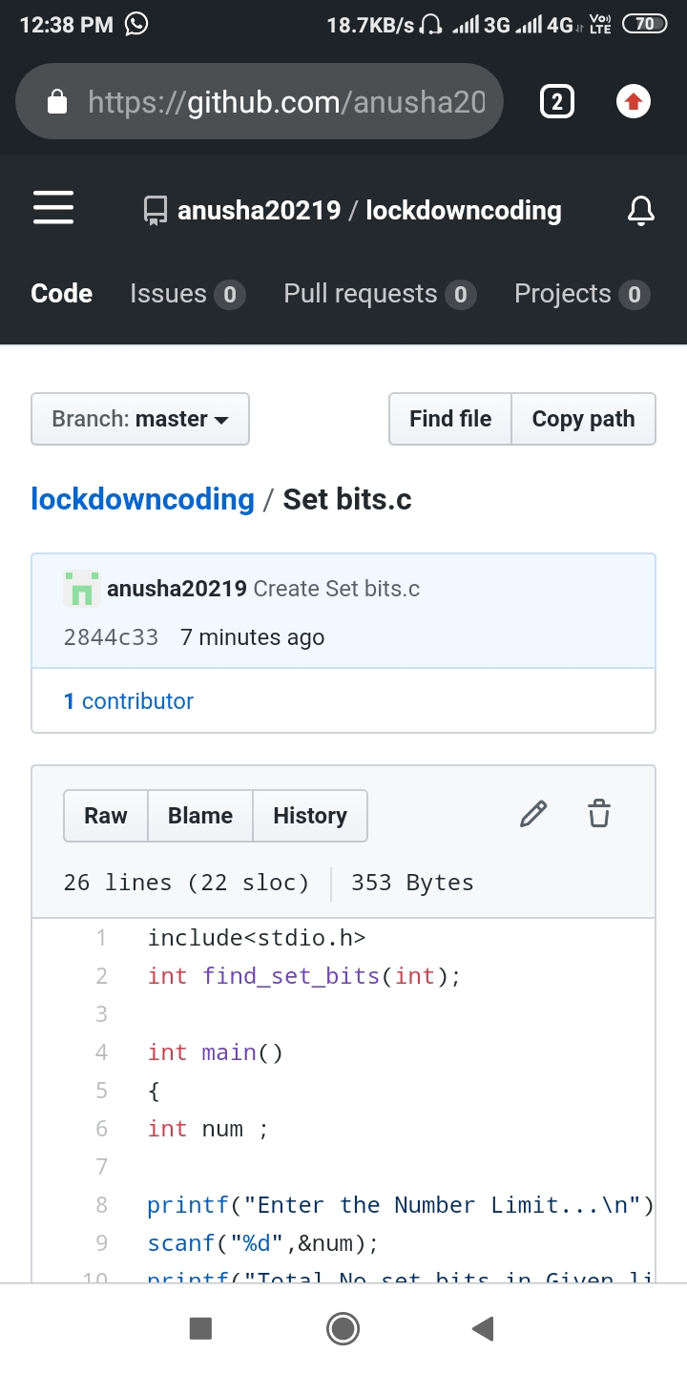Problem statement 01: Write a C Program to Count total set bits in all numbers from 1 to n .